Ex. No. : 03 Date :
Register No. : 221701007 Name : AMRITHA A

Graphical Primitives
Aim
Develop an android application to draw the circle, ellipse, rectangle and some text using Android Graphical primitives.
Procedure:
Step 1 : File → New Project
Provide the application name (e.g.,"GraphicalPrimitives") and click “Next”.
Step 2 : Select the target Android devices
Select the minimum SDK to run the application. Click “Next”.
Step 3 : Choose the activity for the application
By default, choose “Blank Activity”. Click “Next”.
Step 4 : Enter activity name and click “Finish”.
Step 5 : Edit the program
Design Shapes and graphical elements in activity_main.xml or
use Canvas API in kotlin code MainActivity.kt.
Step 6 : Run the application
Two ways to run the application:
1. Running through emulator
2. Running through mobile device

AndroidManifest.xml

<?xml version="1.0" encoding="utf-8"?>
<manifest xmlns:android="http://schemas.android.com/apk/res/android"
package="com.example.graphical primitives">

<application
android:allowBackup="true"
android:icon="@mipmap/ic_launcher"
android:label="@string/app_name"
android:roundIcon="@mipmap/ic_launcher_round"
android:supportsRtl="true"
android:theme="@style/Theme.GraphicalPrimitives">
<activity
android:name=".MainActivity"
android:exported="true">
<intent-filter>
<action android:name="android.intent.action.MAIN" />
<category android:name="android.intent.category.LAUNCHER" />
</intent-filter>
</activity>
</application>

</manifest>

Activity_main.xml

<?xml version="1.0" encoding="utf-8"?>
<LinearLayout xmlns:android="http://schemas.android.com/apk/res/android"
xmlns:tools="http://schemas.android.com/tools"
android:layout_width="match_parent"
android:layout_height="match_parent"
android:orientation="vertical"
tools:context=".MainActivity">

<TextView
android:layout_width="match_parent"
android:layout_height="wrap_content"
android:background="#673AB7"
android:padding="16dp"
android:text="Graphical Primitives"
android:textColor="#FFFFFF"
android:textSize="18sp"
android:textStyle="bold" />

<com.example.graphicalprimitives.ShapesView
android:layout_width="match_parent"
android:layout_height="match_parent"
android:background="#FFFF00" />

</LinearLayout>

MainActivity.kt

package com.example.graphical primitives

import android.os.Bundle
import android.appcompat.app.AppCompatActivity

class MainActivity : AppCompatActivity() {
override fun onCreate(savedInstanceState: Bundle?) {
super.onCreate(savedInstanceState)
setContentView(R.layout.activity_main)

}
}

ShapesView.kt

package com.example.graphical primitives
import android.content.Context
import android.graphics.Canvas
import android.graphics.Color
import android.graphics.Paint
import android.graphics.RectF
import android.util.AttributeSet
import android.view.View

class ShapesView @JvmOverloads constructor(
context: Context,
attrs: AttributeSet? = null,
defStyleAttr: Int = 0
) : View(context, attrs, defStyleAttr) {

// Paints for different shapes
private val circlePaint = Paint().apply {
color = Color.RED
style = Paint.Style.FILL
isAntiAlias = true
}

private val rectanglePaint = Paint().apply {
color = Color.GREEN
style = Paint.Style.FILL
isAntiAlias = true
}

private val squarePaint = Paint().apply {
color = Color.BLUE
style = Paint.Style.FILL
isAntiAlias = true
}

private val linePaint = Paint().apply {
color = Color.BLACK
style = Paint.Style.STROKE
strokeWidth = 5f
isAntiAlias = true
}

private val ellipsePaint = Paint().apply {
color = Color.rgb(255, 165, 0) // Orange
style = Paint.Style.FILL
isAntiAlias = true
}

private val textPaint = Paint().apply {
color = Color.BLACK
textSize = 40f
isAntiAlias = true
}

override fun onDraw(canvas: Canvas) {
super.onDraw(canvas)

val width = width.toFloat()
val height = height.toFloat()

// Calculate grid dimensions
val cellWidth = width / 2
val cellHeight = height / 3

// Draw Circle (top-left cell)
val circleRadius = cellWidth / 4
canvas.drawCircle(
cellWidth / 2, // x-coordinate of center
cellHeight / 2, // y-coordinate of center
circleRadius, // radius
circlePaint
)

// Draw label for Circle
canvas.drawText(
"Circle",
cellWidth / 2 - 50f,
cellHeight / 5,
textPaint
)

// Draw Rectangle (top-right cell)
val rectLeft = cellWidth + cellWidth / 4
val rectTop = cellHeight / 4
val rectRight = cellWidth + 3 * cellWidth / 4
val rectBottom = 3 * cellHeight / 4
canvas.drawRect(
rectLeft,
rectTop,
rectRight,
rectBottom,
rectanglePaint
)

// Draw label for Rectangle
canvas.drawText(
"Rectangle",
cellWidth + cellWidth / 2 - 80f,
cellHeight / 5,
textPaint
)

// Draw Square (middle-left cell)
val squareSize = cellWidth / 2
val squareLeft = cellWidth / 4
val squareTop = cellHeight + cellHeight / 4
canvas.drawRect(
squareLeft,
squareTop,
squareLeft + squareSize,
squareTop + squareSize,
squarePaint
)

// Draw label for Square
canvas.drawText(
"Square",
cellWidth / 2 - 50f,
cellHeight + cellHeight / 5,
textPaint
)

// Draw Line (middle-right cell)
val lineStartX = cellWidth + cellWidth / 4
val lineStartY = cellHeight + cellHeight / 2
val lineEndX = cellWidth + 3 * cellWidth / 4
val lineEndY = cellHeight + cellHeight / 2
canvas.drawLine(
lineStartX,
lineStartY,
lineEndX,
lineEndY,
linePaint
)

// Draw label for Line
canvas.drawText(
"Line",
cellWidth + cellWidth / 2 - 40f,
cellHeight + cellHeight / 5,
textPaint
)

// Draw Ellipse (bottom-left cell)
val ellipseRect = RectF(
cellWidth / 4,
2 * cellHeight + cellHeight / 4,
3 * cellWidth / 4,
2 * cellHeight + 3 * cellHeight / 4
)
canvas.drawOval(ellipseRect, ellipsePaint)

// Draw label for Ellipse
canvas.drawText(
"Ellipse",
cellWidth / 2 - 50f,
2 * cellHeight + cellHeight / 5,
textPaint
)

// Draw Text demo (bottom-right cell)
canvas.drawText(
"Sample Text",
cellWidth + cellWidth / 2 - 90f,
2 * cellHeight + cellHeight / 2,
textPaint
)

// Draw label for Text
canvas.drawText(
"Text",
cellWidth + cellWidth / 2 - 40f,
2 * cellHeight + cellHeight / 5,
textPaint
)
}
}

Output

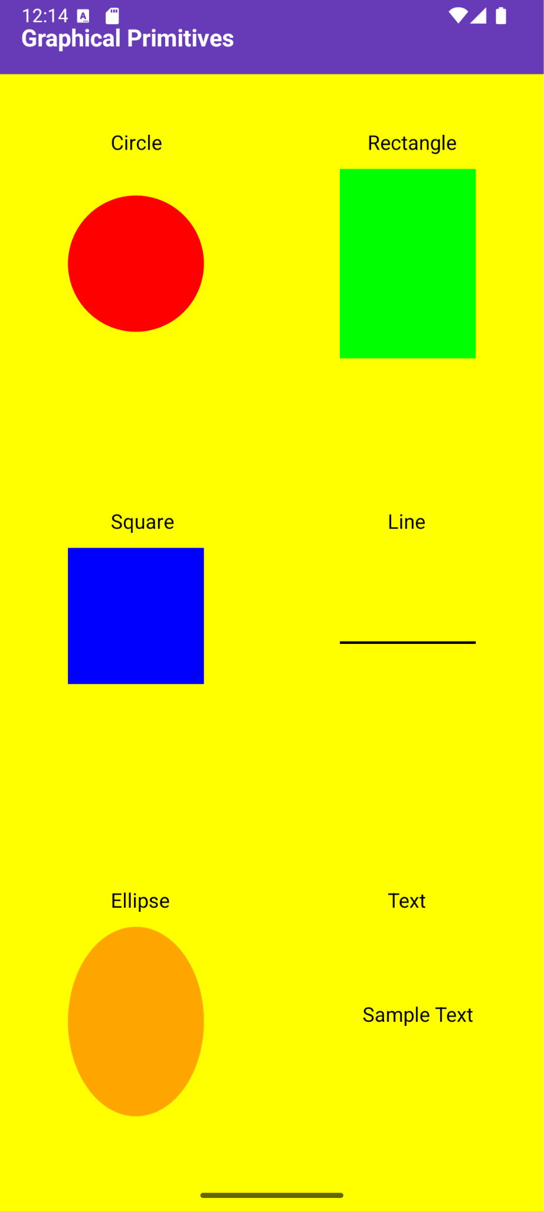

Result:
The Graphical Primitives application successfully displays shapes and graphical elements using Kotlin’s drawing functions when run on an emulator or mobile device.

